CPE301 – SPRING 2019

MIDTERM I

Student Name: Alex Cater

Student #: 2000583031

Student Email:cater@unlv.nevada.edu

Primary Github address: https://github.com/katmando/asdfghjkl.git

Submit the following for all Labs:

1. In the document, for each task submit the modified or included code (only) with highlights and justifications of the modifications. Also, include the comments.
2. Use the previously create a Github repository with a random name (no CPE/301, Lastname, Firstname). Place all labs under the root folder ESD301/Midterm, sub-folder named LABXX, with one document and one video link file for each lab, place modified asm/c files named as LabXX-TYY.asm/c.
3. If multiple asm/c files or other libraries are used, create a folder LabXX-TYY and place these files inside the folder.
4. The folder should have a) Word document (see template), b) source code file(s) and other include files, c) text file with youtube video links (see template).

1. **COMPONENTS LIST AND CONNECTION BLOCK DIAGRAM w/ PINS**

Atmega328PB Xplained Mini

Micro USB Cable (Power Supply)

Wire Connectors

LM35

ESP01

1. **INITIAL/MODIFIED/DEVELOPED CODE**

|  |
| --- |
|  |
| /* |
|  | * midterm1.c |
|  | * |
|  | * Created: 5/1/2019 6:51:03 PM |
|  | * Author : acate |
|  | */ |
|  |  |
|  | #define F_CPU 16000000UL |
|  | #include <avr/io.h> |
|  | #include <stdio.h> |
|  | #include <avr/interrupt.h> |
|  | #include <util/delay.h> |
|  | #define BAUDRATE 115200 |
|  | #define BAUD_PRESCALLER ((F_CPU / (BAUDRATE * 16UL)) - 1) |
|  | #define MAX_1s 15624 |
|  | //Declaration of our functions |
|  | void Timer1_init(void); |
|  | void USART_init(void); |
|  | void adc_init(void); |
|  | unsigned char USART_receive(void); |
|  | void USART_send(unsigned char data); |
|  | void USART_putstring(char* StringPtr); |
|  | void read_adc(void); |
|  | volatile float adc_temp; |
|  | char outs[20]; |
|  |  |
|  | int main(void) { |
|  |  |
|  | DDRD = 0b00000010; |
|  | TIMSK1 |= (1 << OCIE1A); |
|  | sei(); |
|  | Timer1_init(); |
|  | USART_init(); |
|  | adc_init(); |
|  | USART_putstring("Connected!\r\n"); |
|  | _delay_ms(125); |
|  | float adc_tempf; |
|  | USART_putstring("AT+CWJAP=\"WIFI_NAME_HERE\",\"WIFI_PASSWORD_HERE\""); |
|  | while (1) { |
|  | if (TCNT1 == OCR1A) { |
|  | read_adc(); |
|  | adc_tempf = (ADCH << 8) + ADCL; |
|  | adc_tempf = (9/5)*adc_tempf + 32; |
|  | snprintf(outs,sizeof(outs),"%3f\r\n", adc_tempf); |
|  |  |
|  | USART_putstring("AT+CIPSTART=\"TCP\",\"api.thingspeak.com\",80"); |
|  | USART_putstring("AT+CIPSEND=51"); |
|  | USART_putstring("GET /update?key=YR8DHQMB2YJS3AAX&field1=outs\r\n"); |
|  | USART_putstring("AT+CIPCLOSE"); |
|  | } |
|  | } |
|  | return 0; |
|  | } |
|  |  |
|  |  |
|  | void Timer1_init(void) { // Function to Initialize Timer1 properties |
|  | OCR1A = MAX_1s; // Let the OCR1A be the Max Value used for 1s delay |
|  | TCCR1A = (0<<COM1A1)|(0<<COM1A0); // Normal Operation, Disconnected OC1A 'COM1A1:0' |
|  | TCCR1A = (0<<COM1B1)|(0<<COM1B0); // Normal Operation, Disconnected OC1B 'COM1B1:0' |
|  | TCCR1A = (0<<WGM11)|(0<<WGM10); // Set Timer1 to CTC Mode 'WGM1:0' |
|  | TCCR1B = (0<<WGM13)|(1<<WGM12); // Set Timer1 to CTC Mode 'WGM3:2' |
|  | TCCR1B = (1<<CS12)|(0<<CS11)|(1<<CS10); // Set Clock Select '1024' |
|  | } |
|  |  |
|  | ISR(TIMER1_COMPA_vect) { // Function to Truncate Timer1 to delay properly for 1 second |
|  | TCNT1 = 0; // Restart Timer1 from the Beginning |
|  | return; // Resume code from where interrupt left off |
|  | } |
|  |  |
|  | void USART_init(void) { // Function to Initialize USART properties |
|  | UBRR0H = (uint8_t)(BAUD_PRESCALLER >> 8); // Store Upper Baudrate values into UBRR0H |
|  | UBRR0L = (uint8_t)(BAUD_PRESCALLER); // Store Lower Baudrate values into UBRR0L |
|  | UCSR0B = (1 << RXEN0) | (1 << TXEN0); // Enable Receiver and Enable Transmitter |
|  | UCSR0C = (3 << UCSZ00); // Set UCSZ02:1 as 8-bit character data |
|  | } |
|  |  |
|  | unsigned char USART_receive(void) { // Function to receive ASCII value from UDR0 |
|  | while (!(UCSR0A & (1 << RXC0))); // Keep Checking until RXC0 is 'High' to break loop |
|  | return UDR0; // Return received serial into unsigned char data |
|  | } |
|  |  |
|  | void USART_send(unsigned char data) { // Function to transmit ASCII value into UDR0 |
|  | while (!(UCSR0A & (1 << UDRE0))); // Keep Checking until UDRE0 data register 'High' to break loop |
|  | UDR0 = data; // Store unsigned char serial data into UDR0 |
|  | } |
|  |  |
|  | void USART_putstring(char* StringPtr) { // Function to break string into chars, then USART_send() |
|  | while (*StringPtr != 0x00) { // Keep Looping until String Completed (null/0-bits) |
|  | USART_send(*StringPtr); // Send the unsigned char value pointed by the string pointer |
|  | StringPtr++; // Increment pointer to next char array location |
|  | } |
|  | } |
|  |  |
|  | void adc_init(void) { |
|  | ADMUX = (0<<REFS1)|(1<<REFS0)| // Reference Selection Bits, AVcc - External cap at AREF |
|  | (0<<ADLAR)| // ADC Left Adjust Result |
|  | (0<<MUX3)|(1<<MUX2)|(0<<MUX1)|(1<<MUX0);// Analog Channel Selection Bits 'ADC5' (PC5) |
|  |  |
|  | ADCSRA = (1<<ADEN)| // ADC Enable |
|  | (0<<ADSC)| // ADC Start Conversion |
|  | (0<<ADATE)| // ADC Auto Trigger Enable |
|  | (0<<ADIF)| // ADC Interrupt Flag |
|  | (0<<ADIE)| // ADC Interrupt Enable |
|  | (1<<ADPS2)|(0<<ADPS1)|(1<<ADPS0); // ADC Select Bits '32' |
|  | } |
|  |  |
|  | void read_adc(void) { |
|  | unsigned char i = 4; // Set 'i' for iterations |
|  | adc_temp = 0; // set float 'adc_temp' |
|  | while (i--) { // Decrement 'i' until 4 samples take |
|  | ADCSRA |= (1<<ADSC); // If ADSC is high (ADC Start Conversion)... |
|  | while (ADCSRA & (1<<ADSC)); // Start the ADC Conversion |
|  | adc_temp += ADC; // Store the analog value on of current adc_temp |
|  | _delay_ms(50); // delay 50ms for sampling |
|  | } |
|  | adc_temp = (adc_temp/4); // Average of 4 samples taken into adc_temp |
|  | } |
|  |  |

1. **SCHEMATICS**

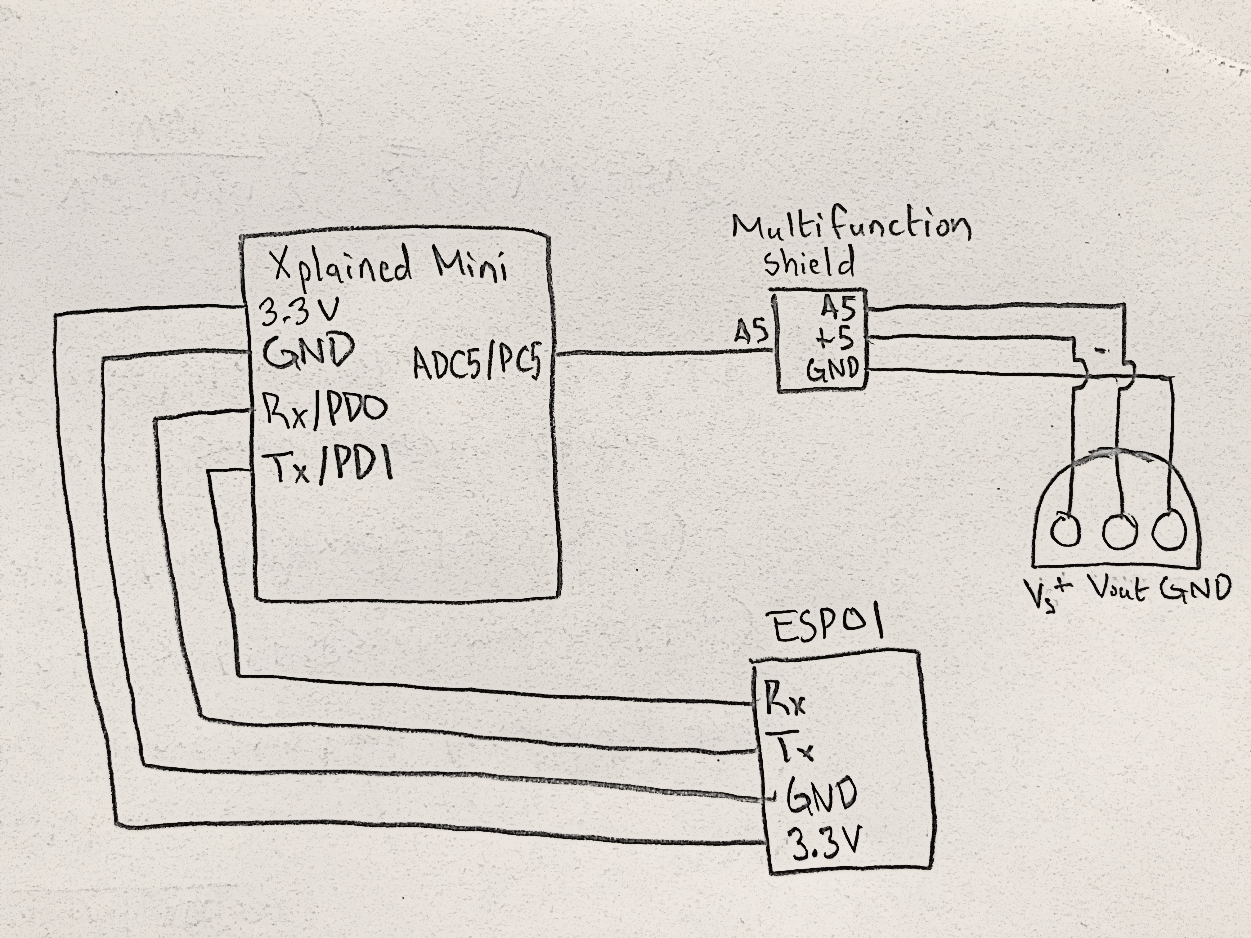

*Figure 1 – Schematic Setup of ESP01 Module*

1. **SCREENSHOTS OF EACH TASK OUTPUT (ATMEL STUDIO OUTPUT)**

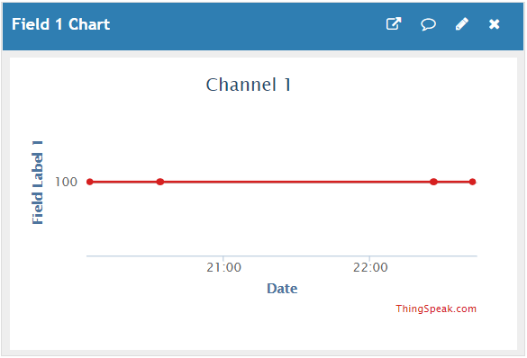

*Figure 2 – Output through ThingSpeak Temperature Reading*

1. **SCREENSHOT OF EACH DEMO (BOARD SETUP)**

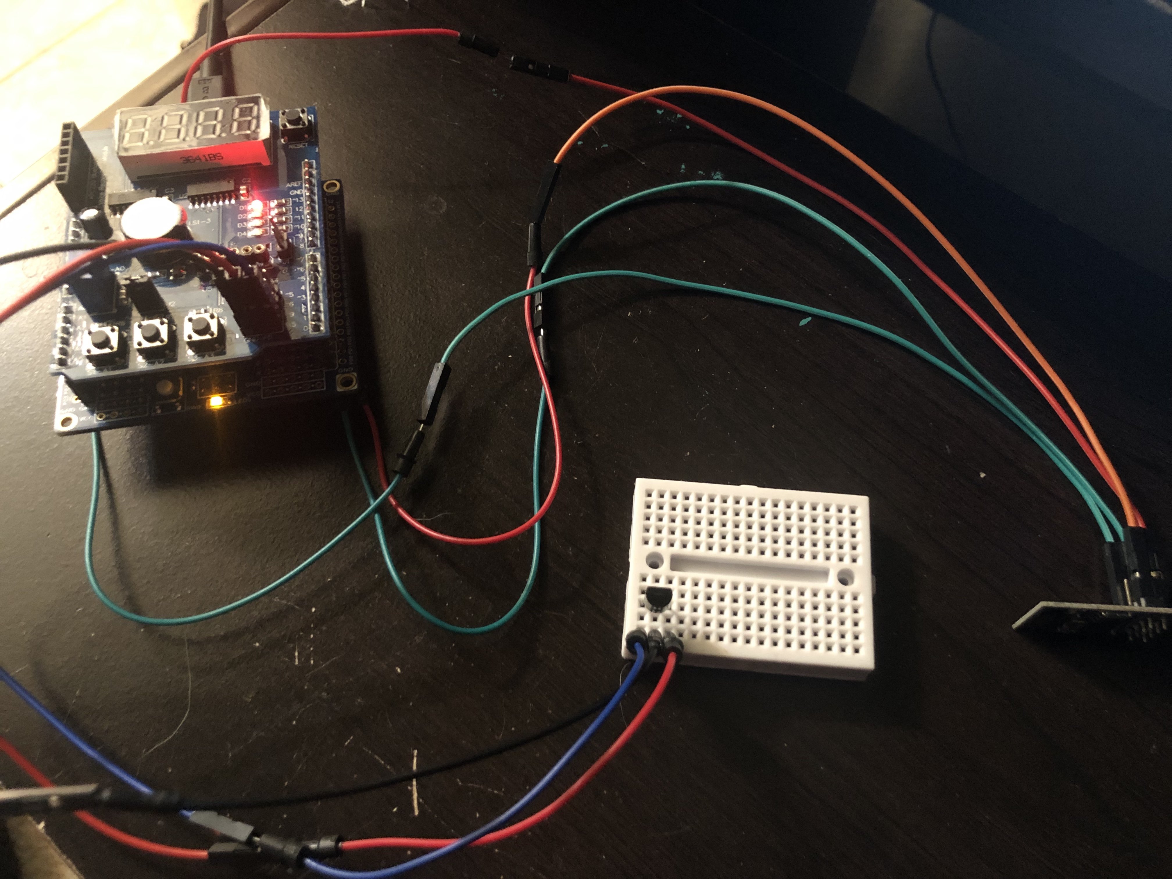

*Figure 3 – Board Setup for ESP01 Modul and Atmega328PB w/ Temperature Sensor*

1. **VIDEO LINKS OF EACH DEMO**

N/A

1. **GITHUB LINK OF THIS DA**

https://github.com/katmando/asdfghjkl/midterm1

**Student Academic Misconduct Policy**

<http://studentconduct.unlv.edu/misconduct/policy.html>

“This assignment submission is my own, original work”.

Alex Cater